**Financing for Health Care Analysis**

**Analysis Report**

**Session - 2022~2023**

SUBMITTED

BY

**SAMBASIVAREDDY S**

GUIDED

BY

**SHALINI KANAGASABAPATHY**

**Table of contents**

1. Aim

2. Objectives

3. Introduction

4. Research Questions

5. Tools and Datasets used

6. Methodology

7. Observations

8. Conclusion

9. Recommendation

10. References

**Aim:**

The primary aim of our project is to collect and analyze the data to create a

Dashboard on Financing for Healthcare.

**Objectives:**

Objective of this project is to find out which country are most spend money to health care and Relationship between Healthcare expenditure and Child Mortality Rate and also Life Expectancy.

**Introduction:**

The objective of this project is to analyze Health Care and Expenditure on Healthcare and create an effective dashboard. The Main Scope of this projects is to seeing the analysis report and dashboard, they know that the How Much Expend on Healthcare and is it Sufficient and If it required to improve in future. This project is useful to analyze Child Mortality Rate and Expenditure on that Country. And Financial Status of Country and How Much They need to Spent. How to overcome the Status of Country Health Status if it in Bad Condition. MS Excel is used for the Data Cleaning. Tableau Desktop is used to Analyze the Data and Visualize the Data by using Dashboards.

**Reference Questions:**1.Which country would have more Child Mortality Rate

2.Which countries mostly spend more in Healthcare. Compare Actual and Expected Expenditure (Top 10)

3.Which country will be show least interest in health insurance taking

4.Compare UK with Top 5 Countries

5.What Percent of Tax revenue will be used for Health Care

6.Size of Population will effect on Health Care. Whether it Positive or Negative

7.Life Expectancy will be good at health care expenditure good countries.

8.Compare developed countries health care Expenditure to developed countries average with Child Mortality rate

9. Is there any factors will affecting on Child Mortality Rate

10. Is there any factors will affecting life expectancy.

11.Is this expenditure Sufficient for Good Health Facilities.

**Tools and Datasets Used:**

* Tableau
* MS Excel
* Dataset Source – Kaggle

Dataset Used

**Methodology:**

**Step 1: Data Collection:**

The dataset was searched and downloaded from the Kaggle website.

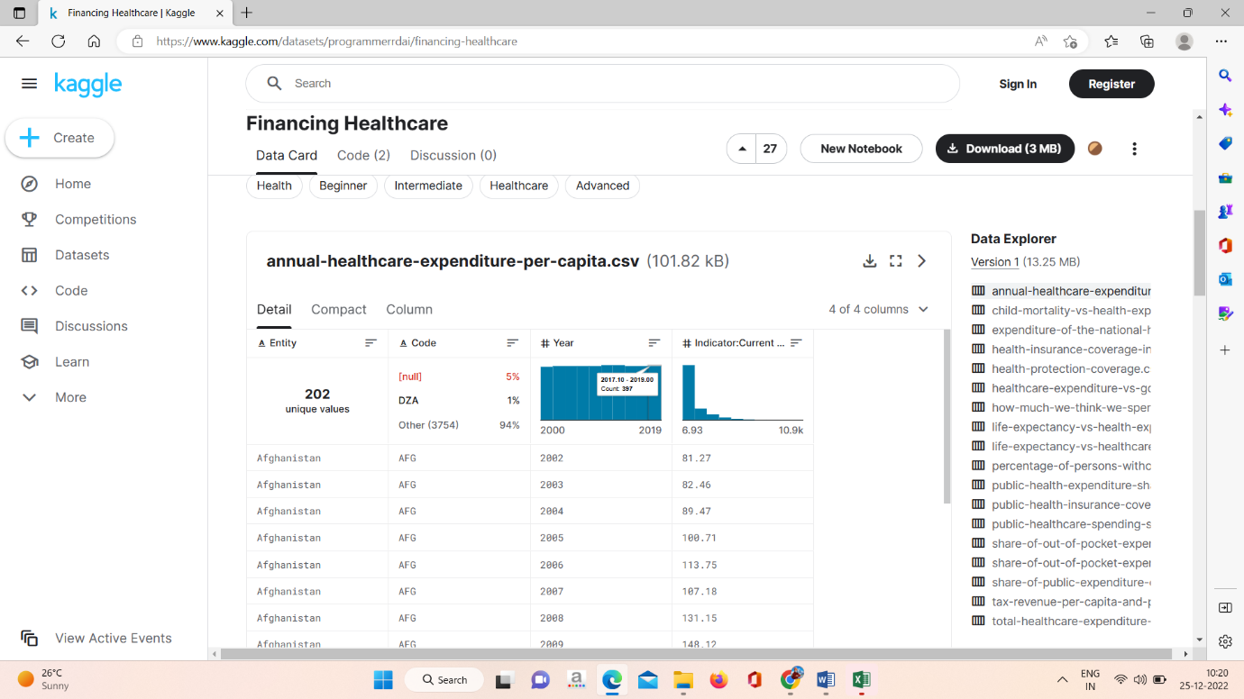

**Step 2: Data Investigation**

The downloaded dataset is checked for any null values and outliers in it. Then done data cleaning and finalized the dataset for the project.

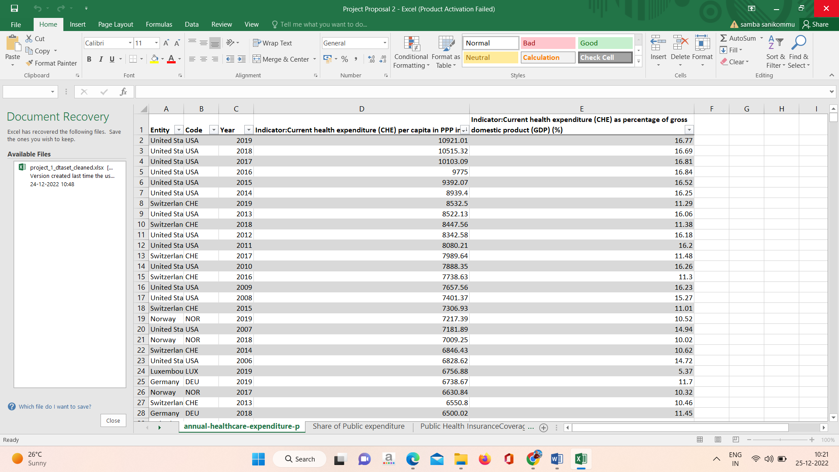

**Step 3: Data Interpretation**

In this step, we use different analytical methods to get a overall summary of the data we use. This will help us to summarize and manipulate the data and conclude it.

**Step 4: Data Visualizations**

This step was the final process in this project. The data in the dataset were used for visualizations and with those data we can able to create a dashboard which will show us detailed insights about the data.

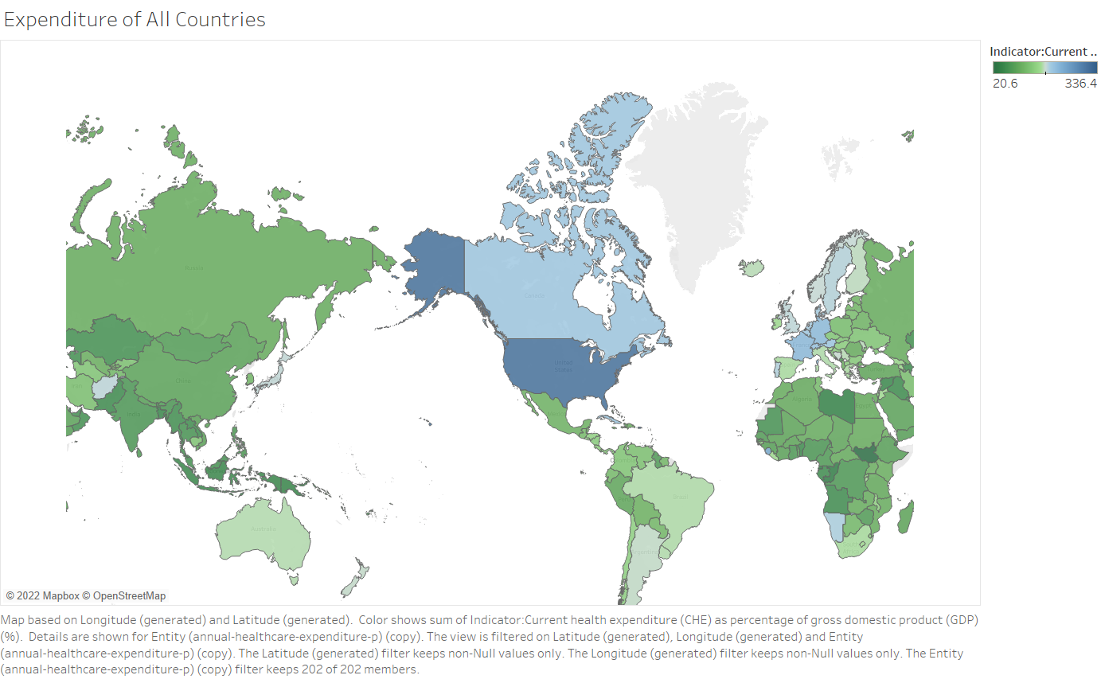

1. **Which country would have more Child Mortality Rate**

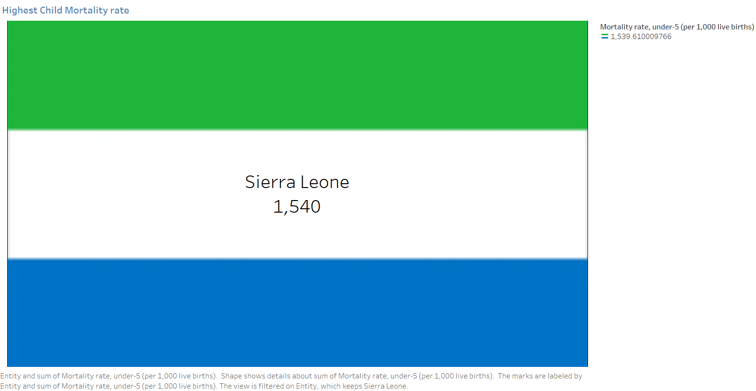

1. **Which countries mostly spend more in Healthcare. Compare Actual and Expected Expenditure (Top 10)**

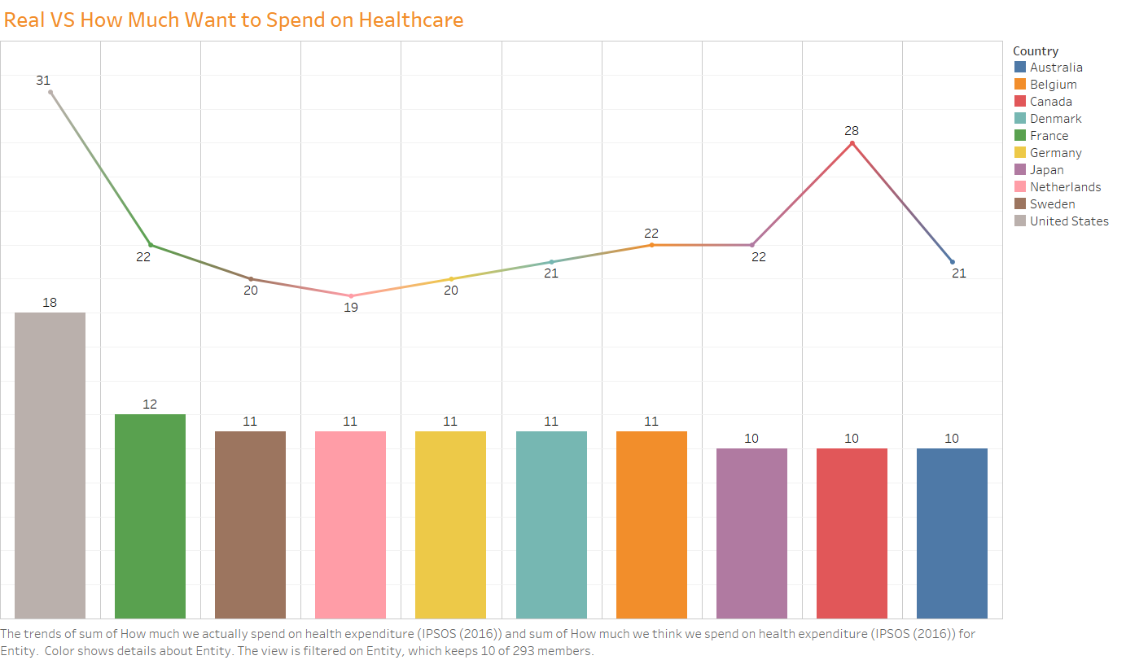

The above chart shows Top 10 Countries which spend more money to health care and Plot shows how much they want to spend and how much they really spend also.

1. **Which country will be show least interest in health insurance taking**

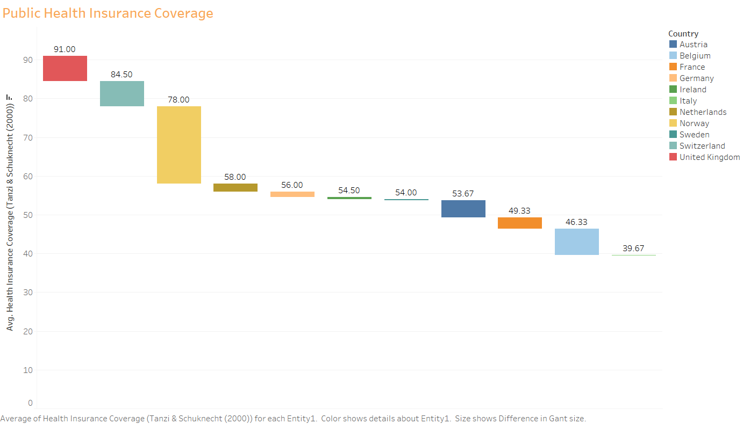

This plot shows how much percent of people taking insurance coverage in different countries. From this graph, we can see that Italy shows least interest to take Insurance Coverage.

1. **Compare UK with Top 5 Countries**

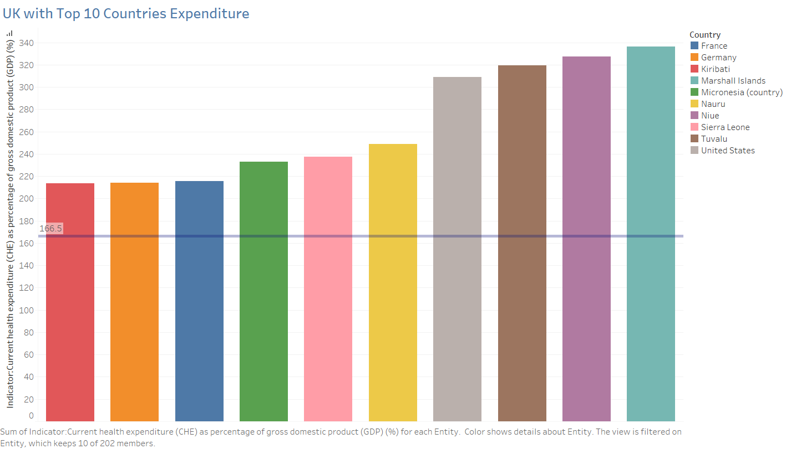

This plot shows the UK Expenditure with Top Countries UK Expenditure as Shows as Reference Line. 166.5% of GDP income Used as Health Expenditure in UK.

1. **What Percent of Tax revenue will be used for Health Care**

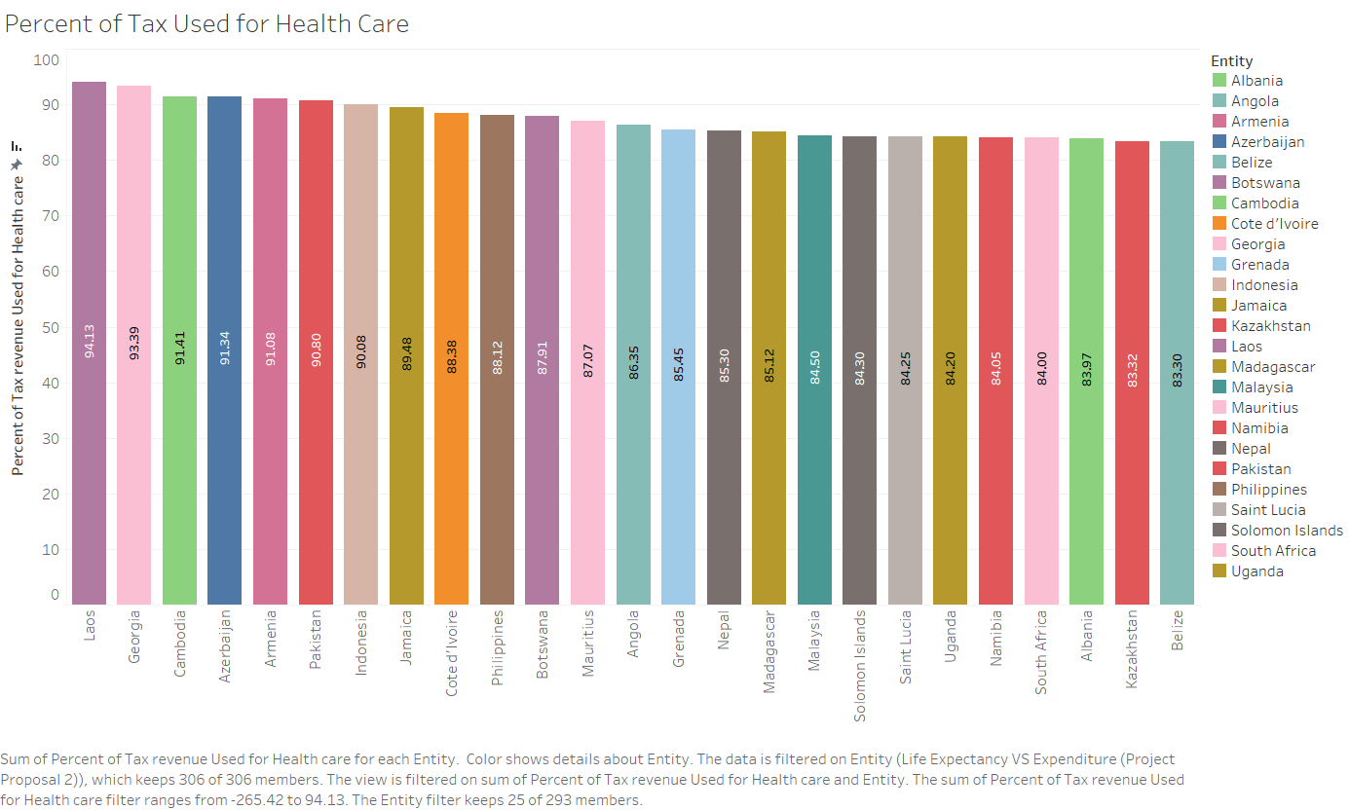

The above Plot Shows How much Percent of Tax Used for Healthcare for difference Countries. Laos and Georgia countries spend 94% and 93% of Tax is Used for Health Expenditure.

1. **Size of Population will effect on Health Care. Whether it Positive or Negative**

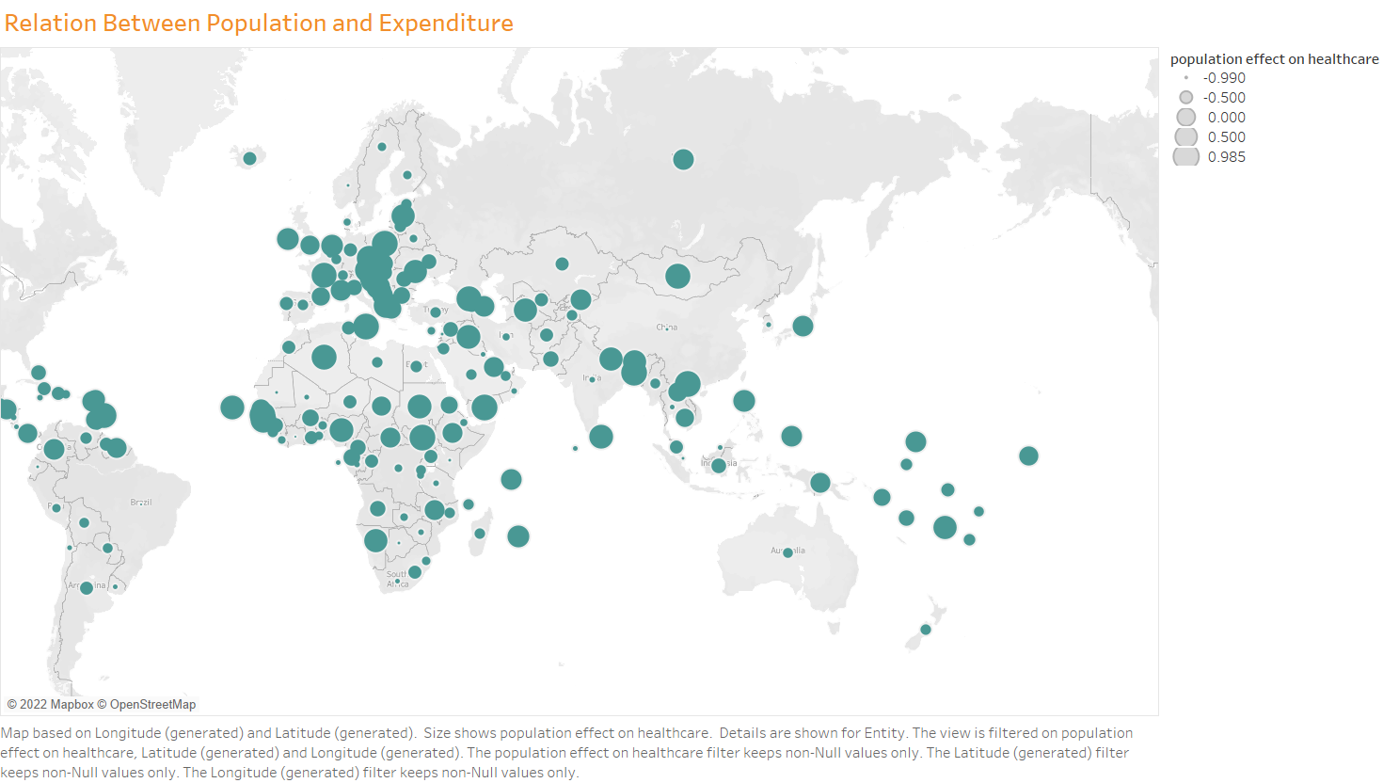

This plot shows the Population, Healthcare Expenditure correlation as Bubbles. Where Population size is more Then Correlation is negative So More Population Countries Have Not Sufficient Expenditure. So Population Less Expenditure is Less.

1. **Life Expectancy will be good at health care expenditure good countries**

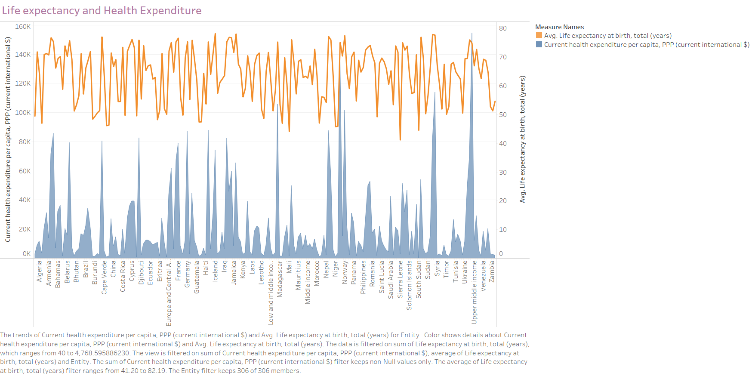

This Plot Shows Life Expectancy with Expenditure. Most Probably We Say Top Expenditure Impact Good Life Expectancy. Least Expenditure Countries Probably Least Life Expectancy.

1. **Compare developed countries health care Expenditure to developed countries average with Child Mortality rate**

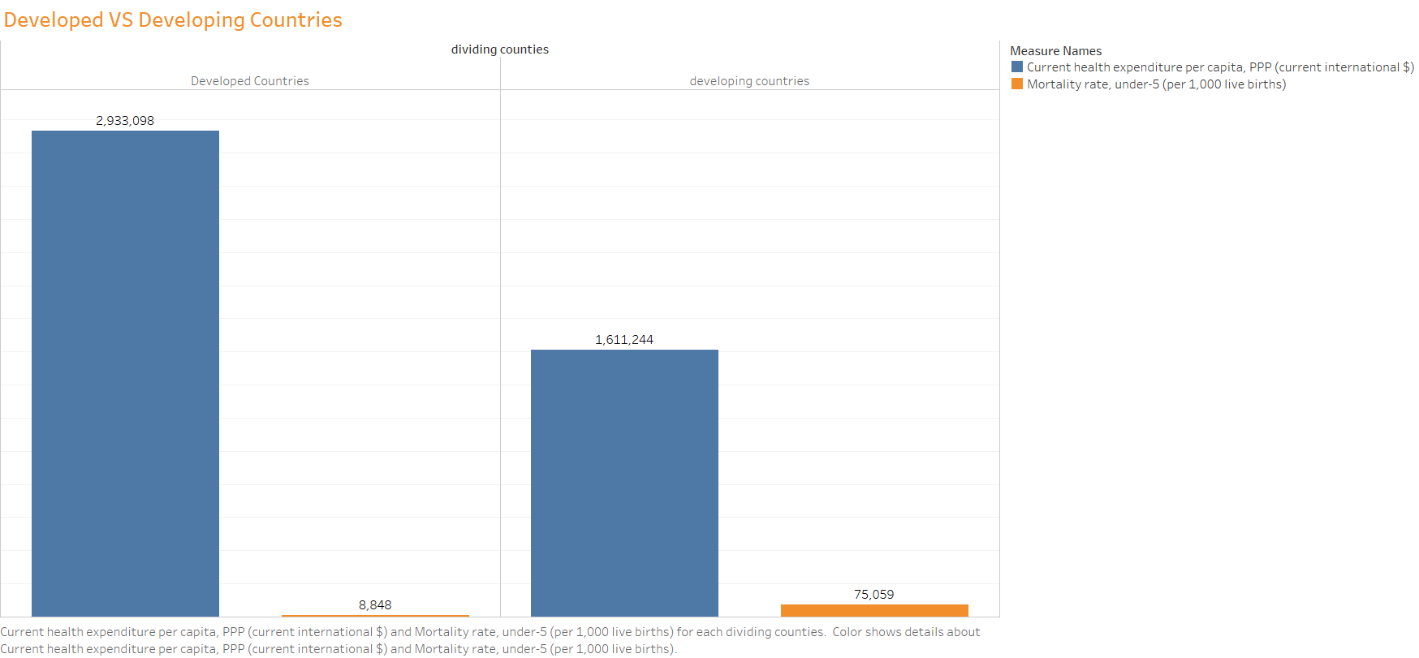

This plot shows Comparison Between Developed and Developing Countries Expenditure and The Child Mortality Rate.

1. **Is there any factors will affecting on Child Mortality Rate**

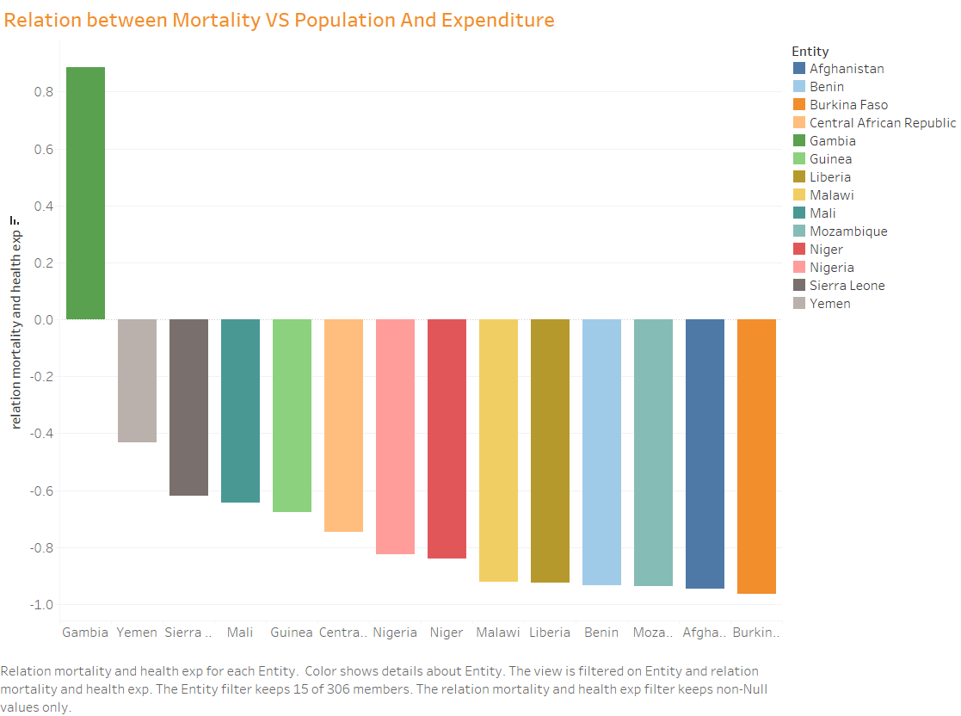

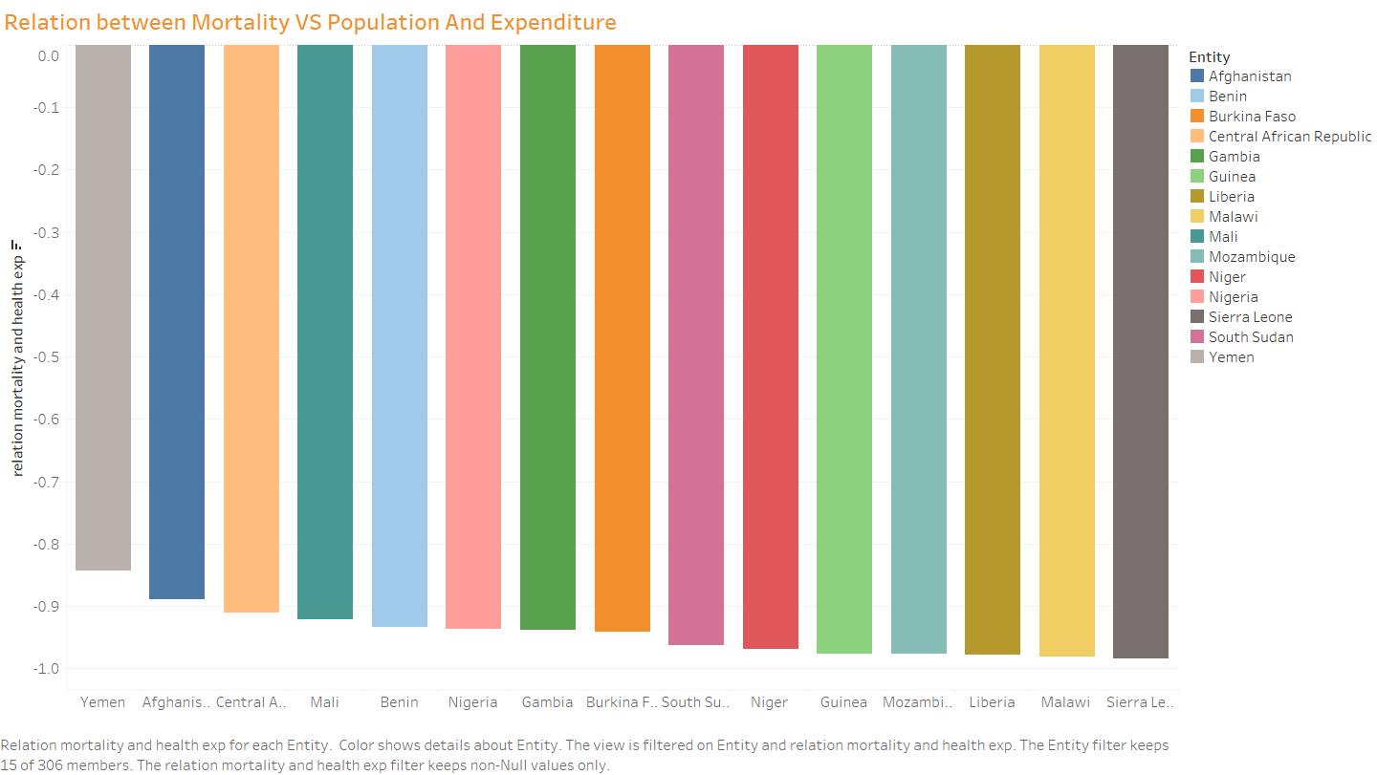

This plots shows Different countries Child Mortality Rate with Relation to Expenditure and the Population. Most probably we say that Child Mortality Rate will Increase with Population. But Expenditure are Increases with decrease with in some countries and vice versa in some countries.

1. **Is there any factors will affecting life expectancy**

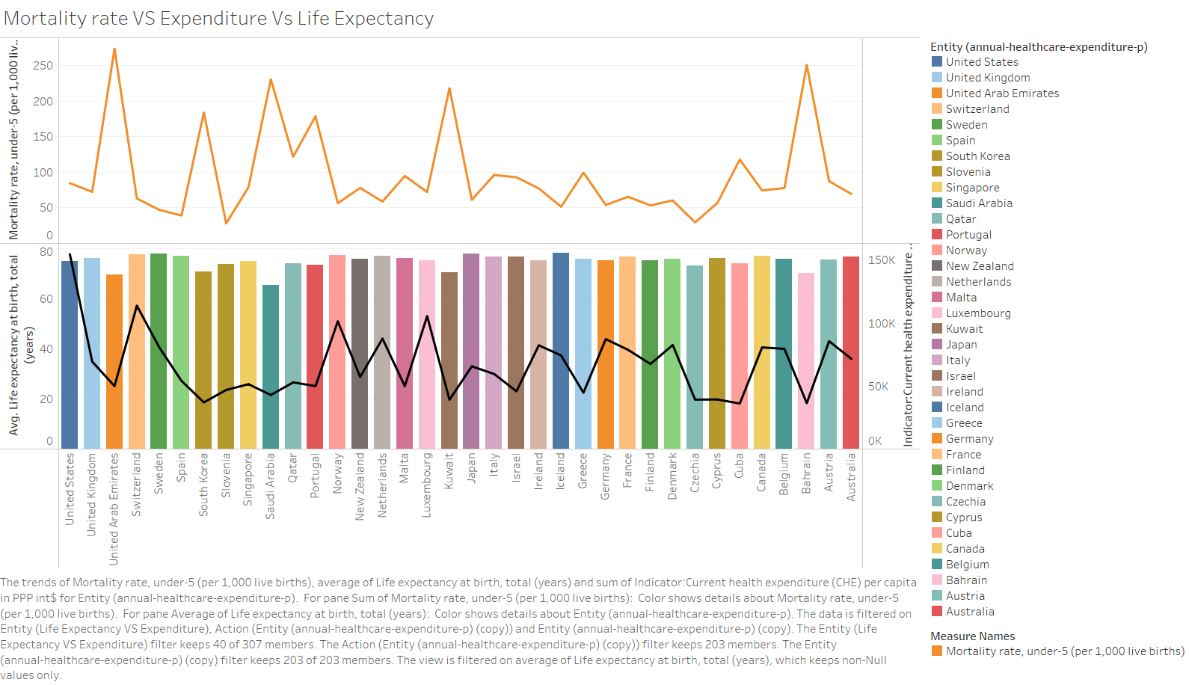

This plot shows Mortality Rate, Life Expectancy, Expenditure. Life Expectancy More Where Expectancy is high and Child Mortality Rate is low. And Vice Versa.

1. **. Is this expenditure Sufficient for Good Health Facilities**



This plot shows the Suggestions for different countries to increase Expenditure.

Green Shaded Countries should increase Expenditure for Health care.

**Observations:**

1. Sierra Leone Country Have high Child Mortality Rate 39 persons Per Every 1000 Live Births.
2. US Invest More Income for Healthcare Expenditure 154593$.
3. Laos Country Invest 94% of Tax Revenue is used for Healthcare Expenditure.
4. Italy Shows Least Interest in Insurance Coverage. UK shows High Interest.
5. Developed Countries are in Less Number but High Expenditure for Healthcare, Low Mortality Rate.
6. Developing Countries are in More Number but High Child Mortality Rate, Least Expenditure for Healthcare

**Conclusion:**

1. We can conclude that India Spend 71.66% GDP invest for Healthcare Expenditure and 2936$.
2. We can conclude that Child Mortality Rate of India is 24 persons for Every 1000 Live Births.
3. India is also one of the Developing Country and Life Expectancy of people is 57 Years.

**Recommendations:**

1. India has to Control Population because High Population leads to not Sufficient fund to Expenditure.
2. We can also Suggest the India Has to Increase GDP when Compare through GDP It is in Good Position but Compare to Money It Invest Least Money.
3. India Has to Focus Reduce the Child Mortality Rate also Its not less nearer to Maximum 39 persons.

**References:**

**Financing Analysis for Healthcare**

(<https://www.kaggle.com/datasets/programmerrdai/financing-healthcare>)